NATIONAL UNIVERSITY OF COMPUTER AND EMERGING SCIENCES

**(**KARACHI CAMPUS)

FAST School of Computing

Fall 2023

**PROJECT REPORT**

**TASK PRO**

**GROUP MEMBER NAMES:**

SYEDA FAKHIRA (22K-4413)

AAFREEN (22K-4448)

MUHAMMAD TAHA (22K-4458)

***INSTRUCTOR: MS MUBASHRA FAYYAZ***

### 

### 

### 

### 

### 

### 

### 

### **TABLE OF CONTENTS**

### 

### MAIN IDEA....................................................................................................................................

### WORK DISTRIBUTION:...............................................................................................................

### CODE DETAILS............................................................................................................................

### CLASSES USED...........................................................................................................................

### GOALS............................................................................................................................................

### TOOLS AND TECHNOLOGIES...................................................................................................

### LIBRARIES USED.........................................................................................................................

### FUNCTIONS.................................................................................................................................

### FUTURE WORK ...................................................................................................................................

### PROBLEMS ENCOUNTERED...................................................................................................................

### 

### 

### 

### 

### 

### 

### 

### 

### **MAIN IDEA**

The purpose of our project is to help users organize their tasks and simplify their daily routines. This project consists of various kinds of lists, such as: academic, shopping, personal, events, and wish list. This project has several classes which include:

* User class
* Task class
* List class
* Feedback class

The Task pro project has the following are the basic functionalities:

* User class: This class will have login and registration functionality. Every user will have multiple linked lists so the User class will have:
* An array of objects of class List, name, user ID, password, code
* Task class: Task class will act as the nodes in the linked list. It will have attributes, namely:
* Deadline, Current date, Details, Status, Category, Task *next
* List class: In this class, each user will have lists of tasks according to the categories.
  + It will have an attribute of the head keeping track of the starting of a linked list.
  + Insertion (user will enter task name, deadline, current date, status, details, and category).
  + Users can update, delete, archive, search for tasks.
  + Tasks can be sorted on the basis of deadline, status and details.
* Feedback system where the user can give feedback.

### 

### **WORK DISTRIBUTION**

### **GROUP WORK: deciding basic project structure**

| NAME | CONTRIBUTION |
| --- | --- |
| SYEDA FAKHIRA SAGHIR | Main, linked lists basic functions, tasks class |
| AAFREEN MUGHAL | feedback class, user class structure, linked list functions |
| MUHAMMAD TAHA | linked lists basic functions sorting(status, detail), filing |

### **CLASSES USED**

* Task class
* List class
* User class
* Feedback class

**LIBRARIES USED:**

* #include<iostream>
* #include<string>
* #include<time.h>
* #include<fstream>
* #include<stdio.h>
* #include<windows.h>
* #include<stdlib.h>

### **GOALS**

The goal of the Data Structures To-Do List project is to build a reliable task management system by utilizing a variety of data structures to implement key functionality. The project entails creating and putting into place processes for adding, deleting, updating, and marking tasks as finished. Sorting and searching algorithms are used to organize and retrieve tasks based on priority, due dates, status, task details or other criteria. And the main aim of this project is to enhance our coding skills and develop a strong command over various data structures.

### **FUNCTIONAL GOALS**

* **Task Management:**

- Users should be able to add tasks with details such as task name, description, due date, and priority.

- Tasks should be removable and updatable, allowing users to modify details or mark tasks as completed.

* **Sorting and Searching:**

- Allow users to sort tasks by different criteria, such as priority or due date.

- Implement searching functionality to quickly locate specific tasks within the list.

* **Task Filtering:**

- Allow users to filter tasks based on different criteria, such as completed tasks, overdue tasks, or tasks with a specific priority.

* **Task Reminders:**

- Optionally, implement a reminder system to notify users of approaching due dates or incomplete tasks.

* **Task Categories:**

- Optionally, allow users to categorize tasks into different groups or projects for better organization.

**OUTPUT SNIPPETS**

### If user is already registered check in file:

### 

Registering a User:

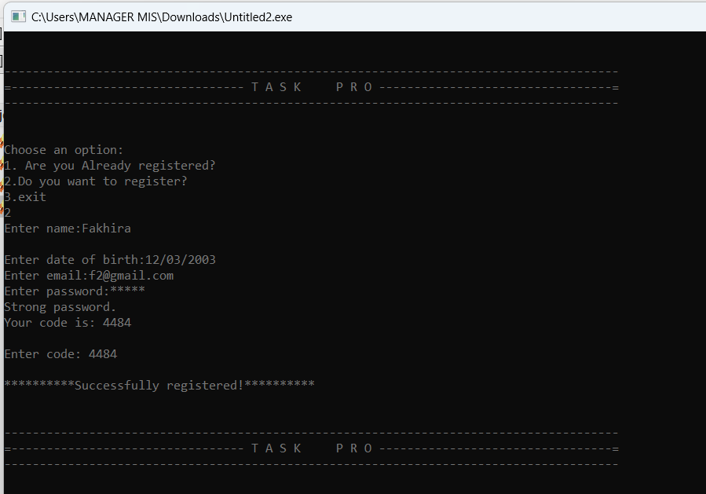

Asking for User’s Choice of list and then asking them to choose a functionality: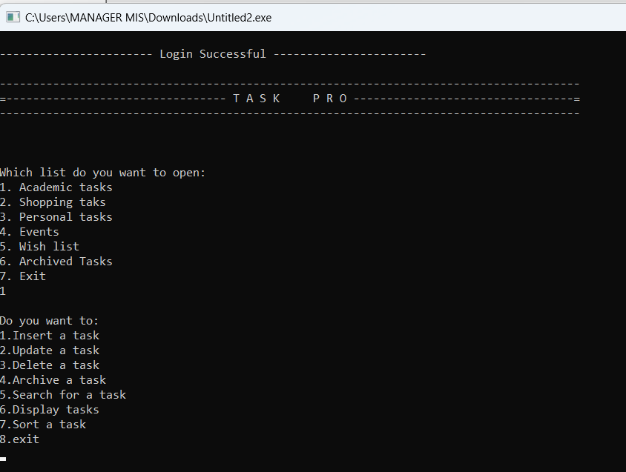

Inserting Tasks:

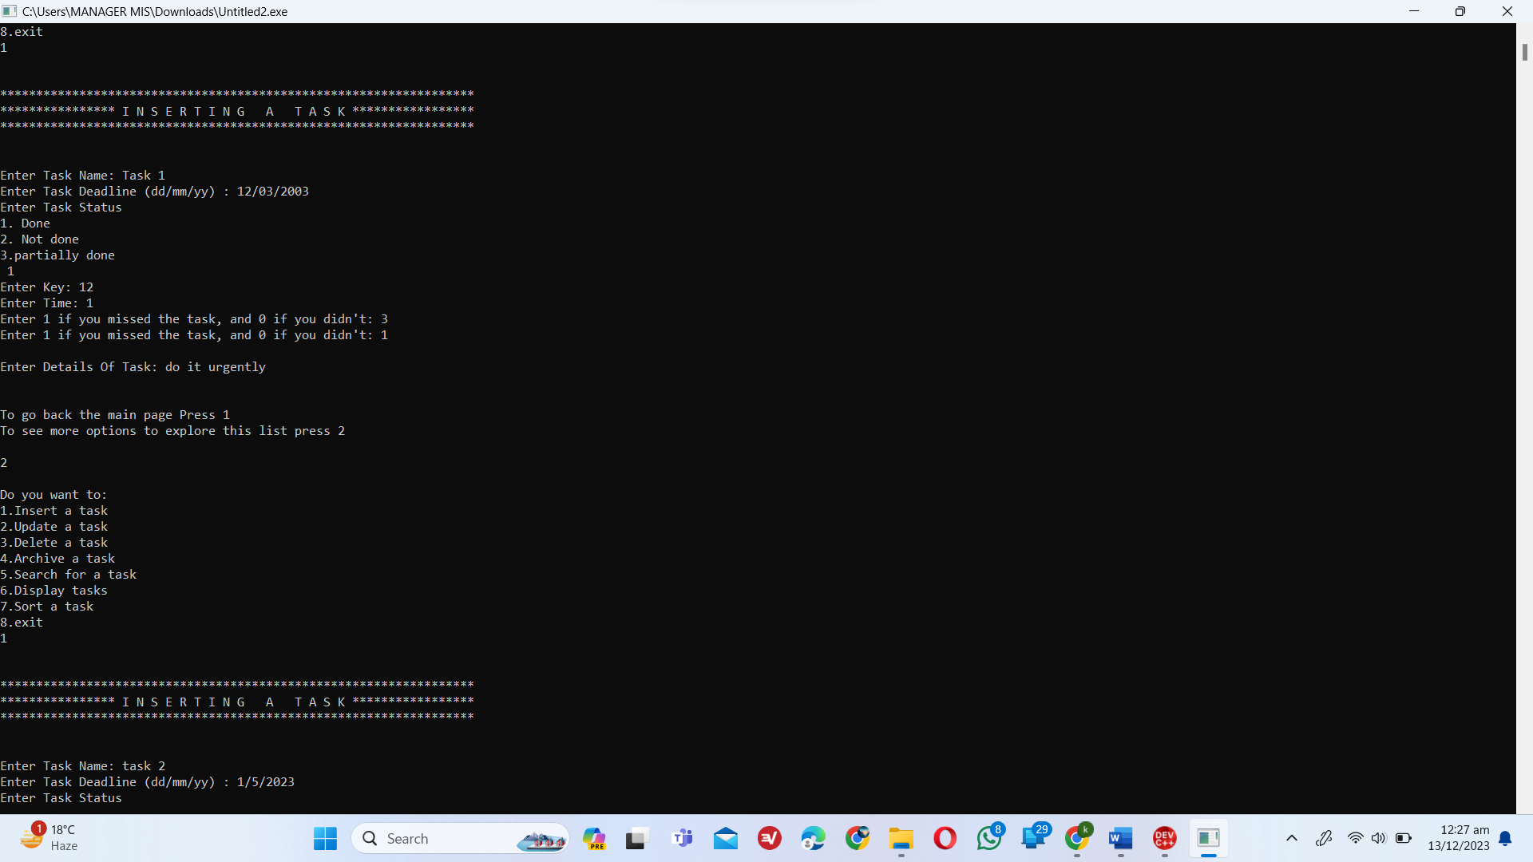

Searching a Task

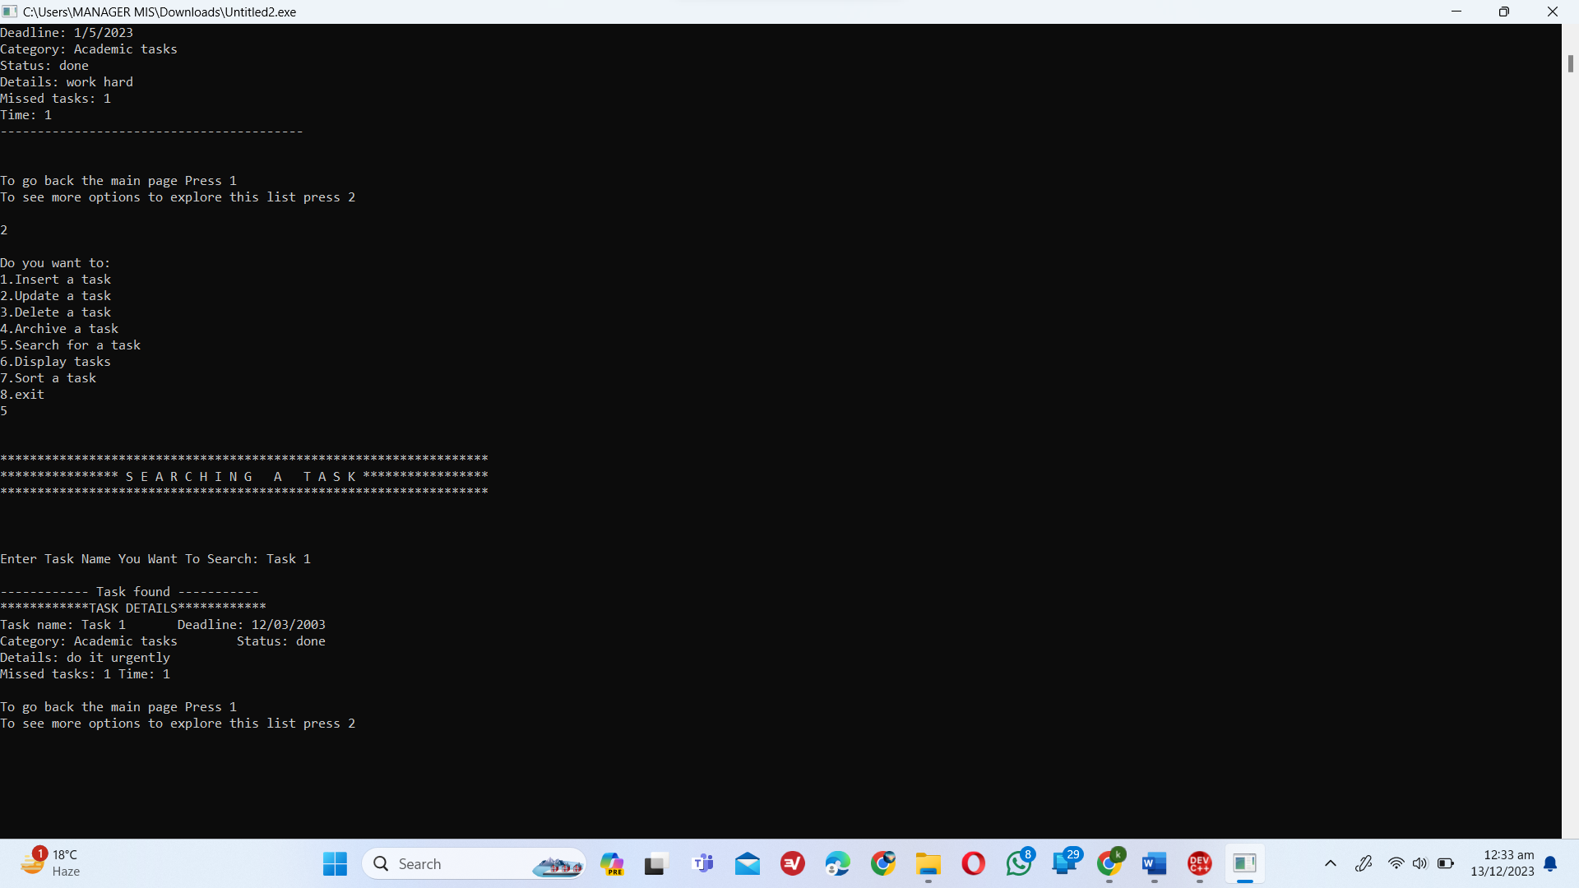

Updating a Task

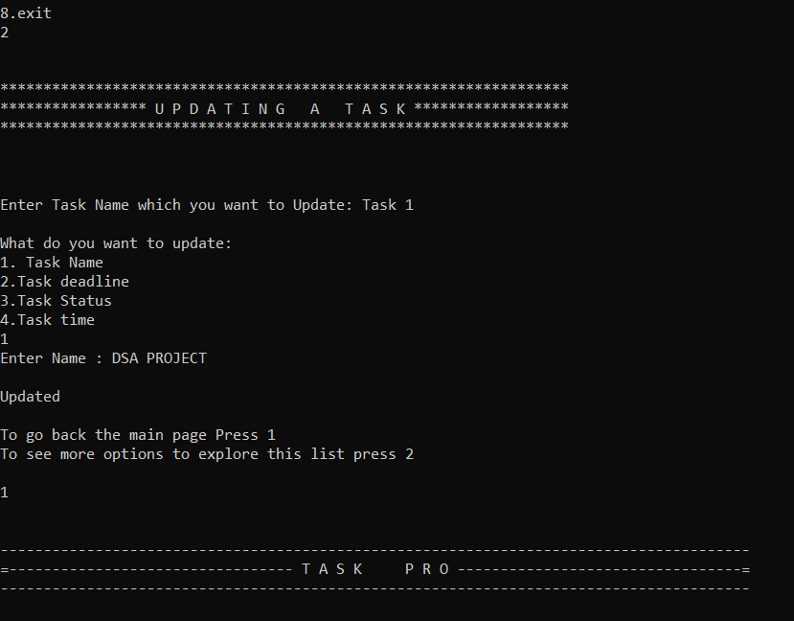

Archiving a Task

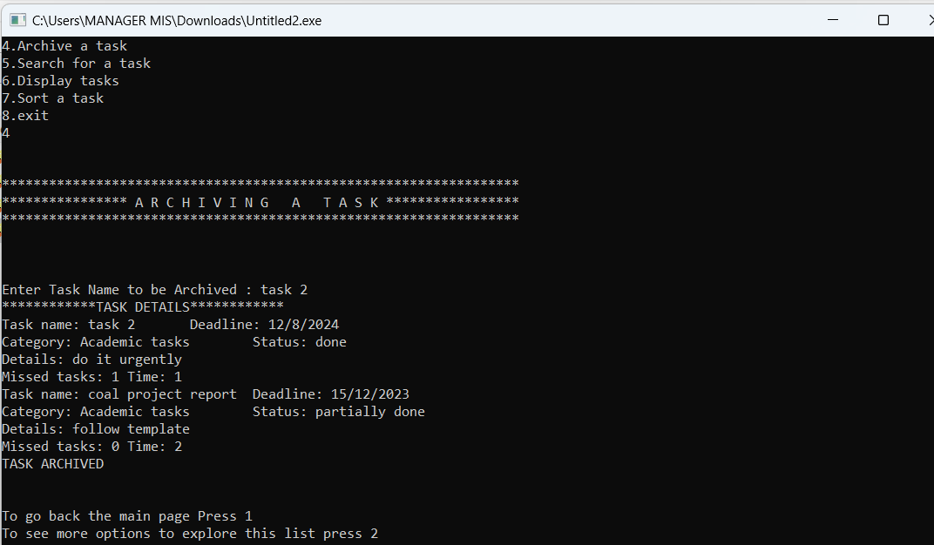

Sorting According To Deadline

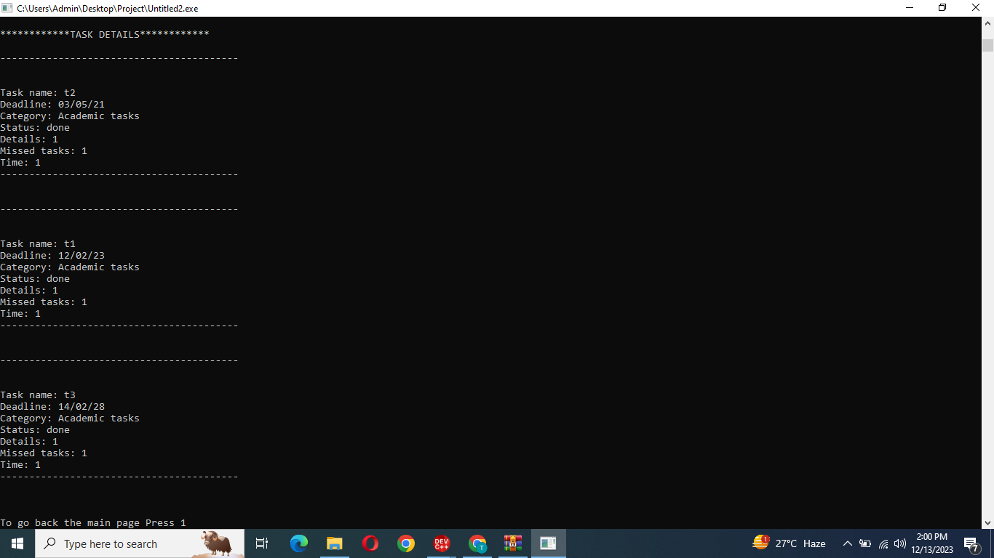

Sorting According To Details:

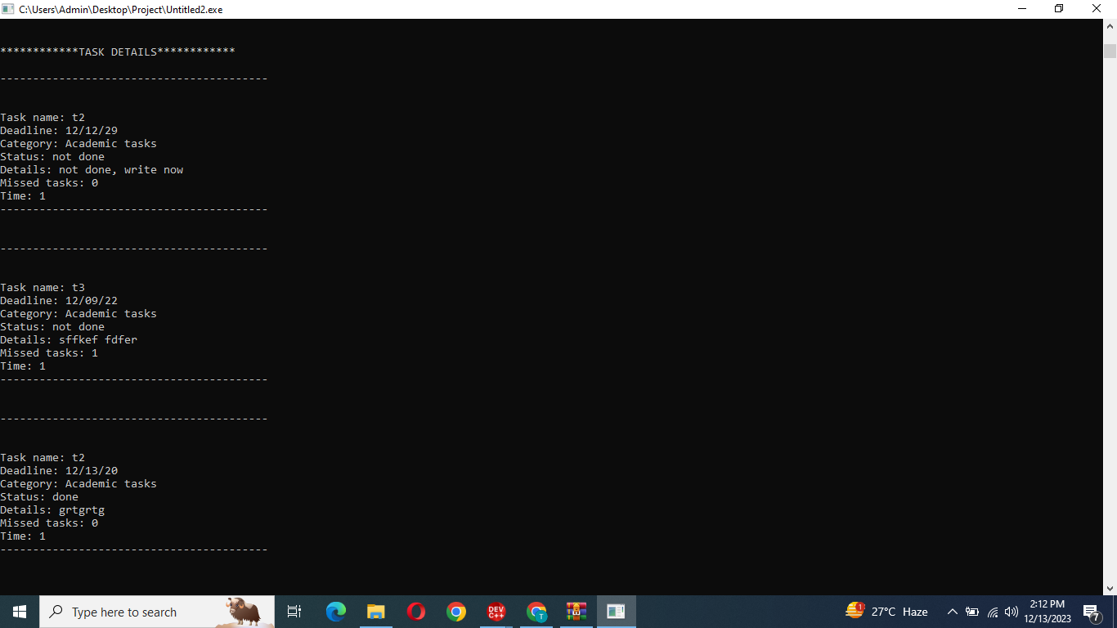

Sorting According To Status:

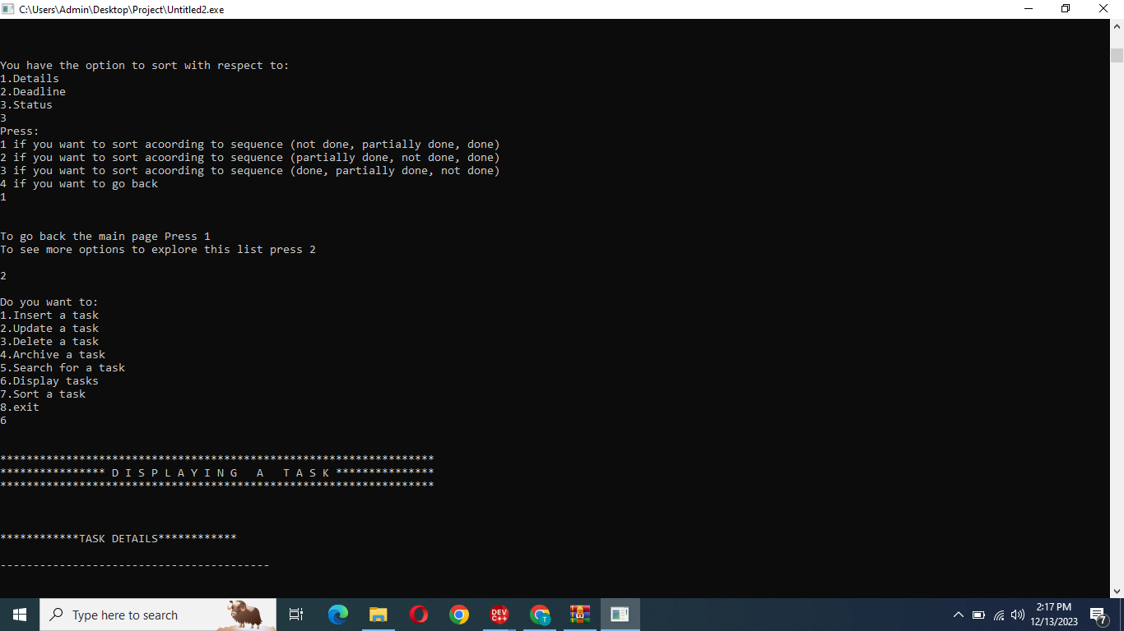

### 

### Feedback asked when ever wrong input entered

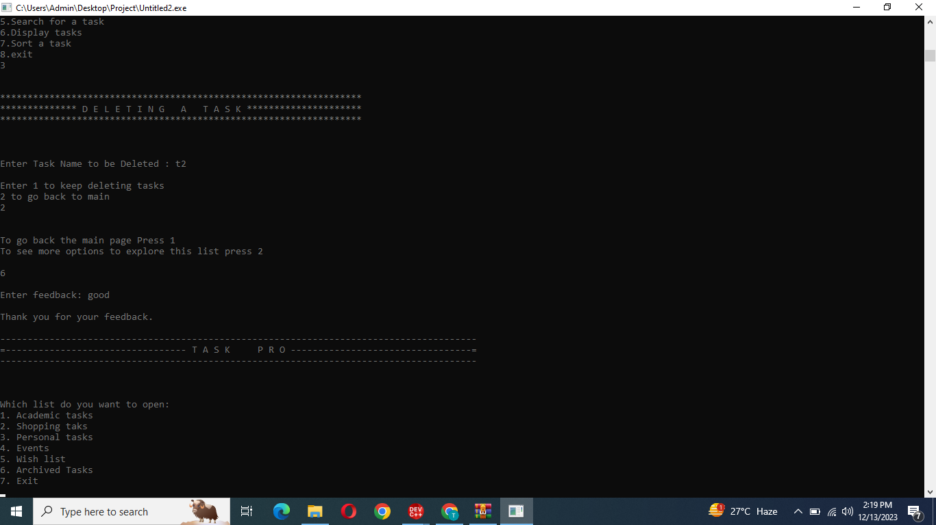

### 

### Deleting a task

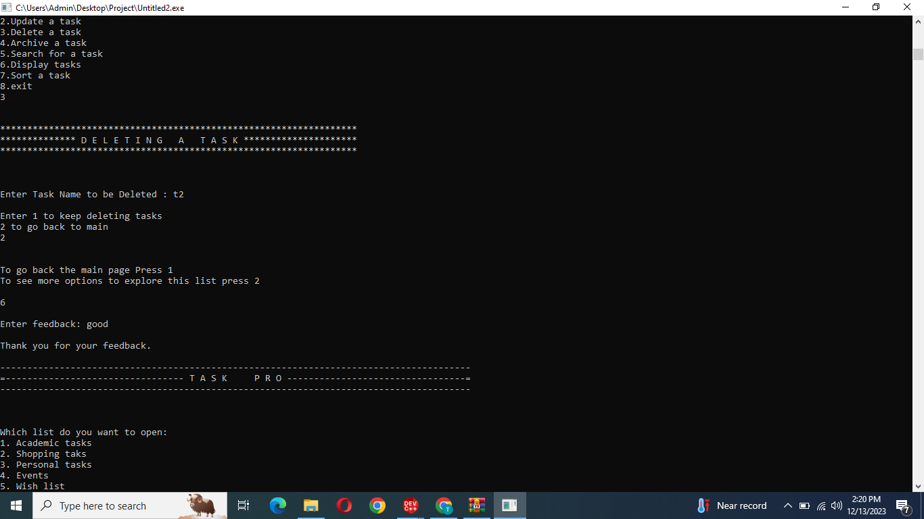

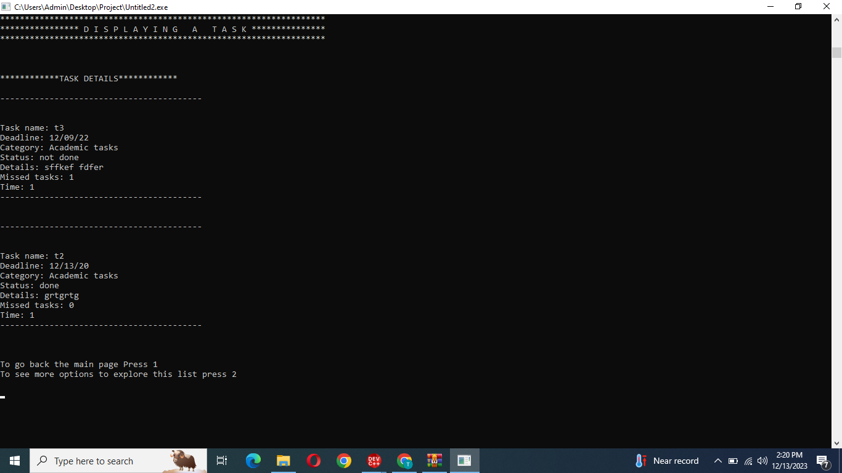

### 

### **TOOLS AND TECHNOLOGIES**

### IDE: DEV C++ / VISUAL STUDIO

### **FUNCTIONS**

* Task class:
* Setters and getters for every attribute
* User class:
* Input User details
* Display User details
* List class:
* Setters and getters for every attribute
* Insert Task
* Search Task
* Sorting(deadline, details, status)
* Update task details
* Delete task
* Archive task
* Feedback class:
* Setters and getters for every attribute
* Feedback input
* Input Function
* chooseList function

### 

### **FUTURE WORK**

To-Do List project, future work could involve enhancements, new features, and improvements to make the system more robust and user-friendly. It will help us in

* Mobile App development
* Advance sorting algorithms
* Feedback mechanism
* Automated task generation

### 

### **PROBLEMS ENCOUNTERED**

* Difficulty while writing an object in a file
* Issue was sorting the deadline .Extracting dates from the string was a bit tricky ,however we manage to resolve it by discussing different methods to extract dates

### 